**COMPUTER NETWORKS (LAB MANUAL -USING PACKET TRACER)**

**B. Priyanka (192111524)**

**1A.HUB:**

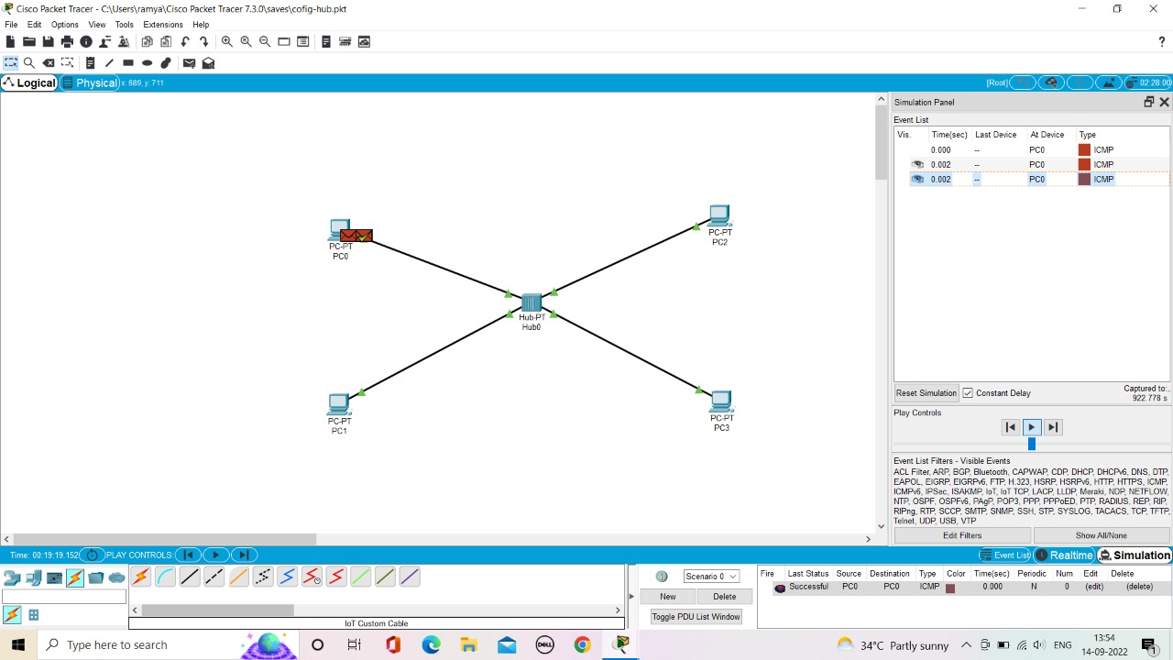

**1B.SWITCH:**

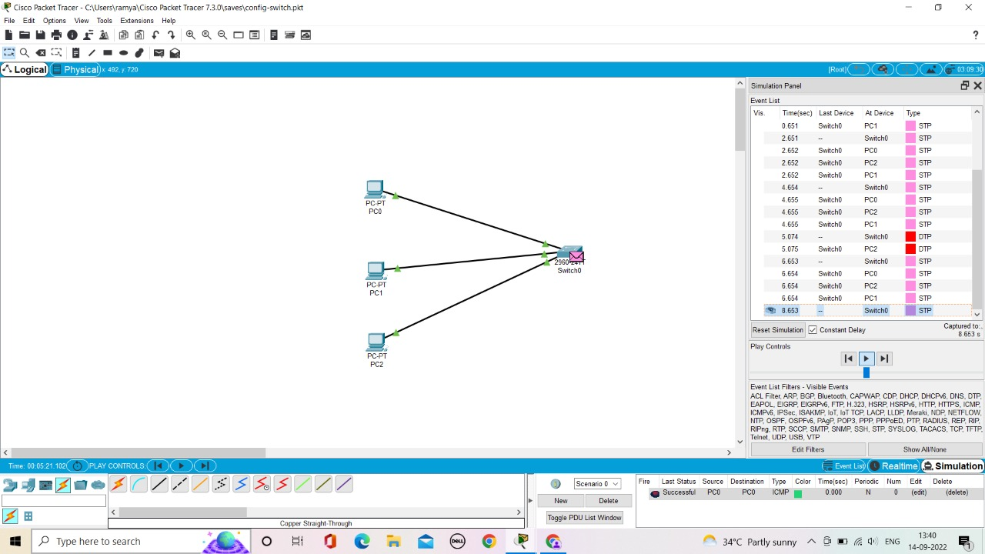

**1C.ETHERNET:**

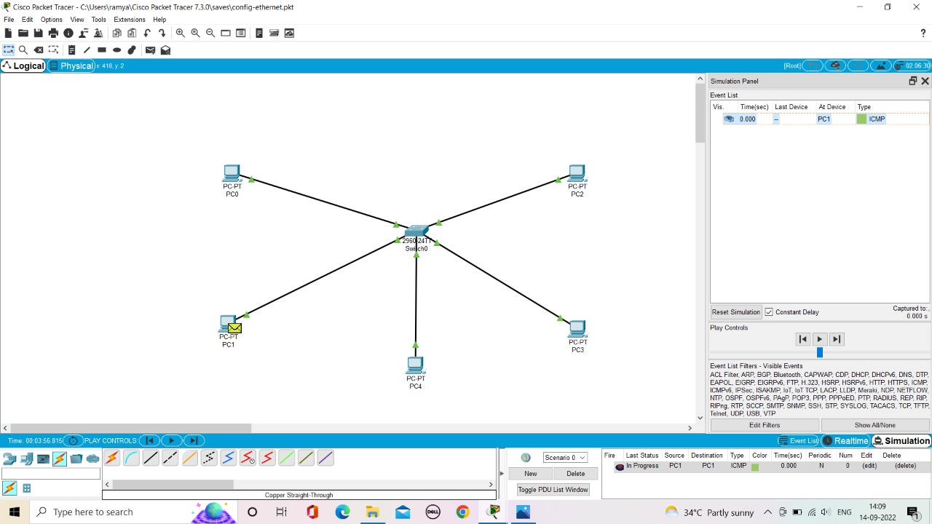

**1D.BROADCAST:**

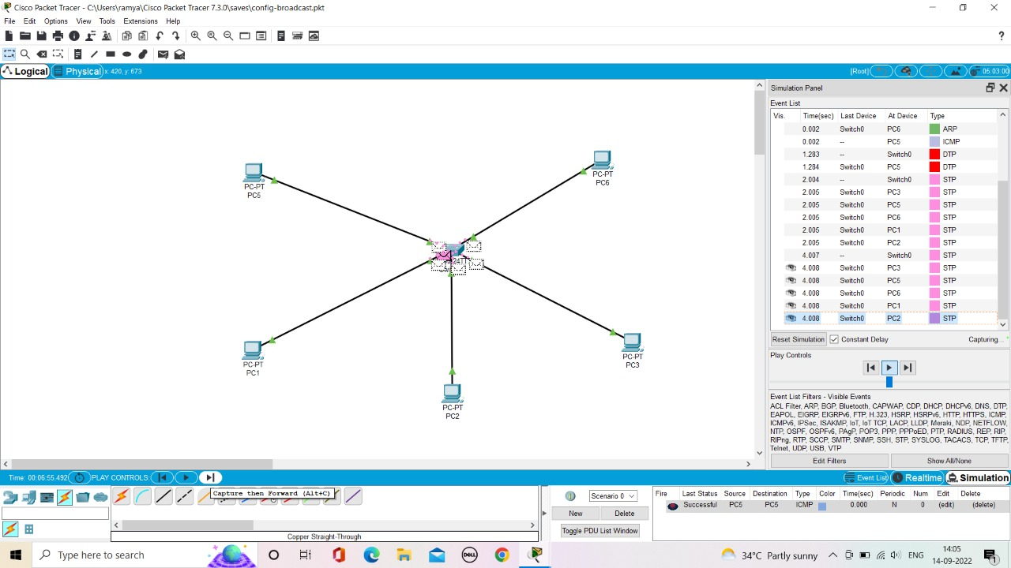

**2.BUS TOPOLOGY**

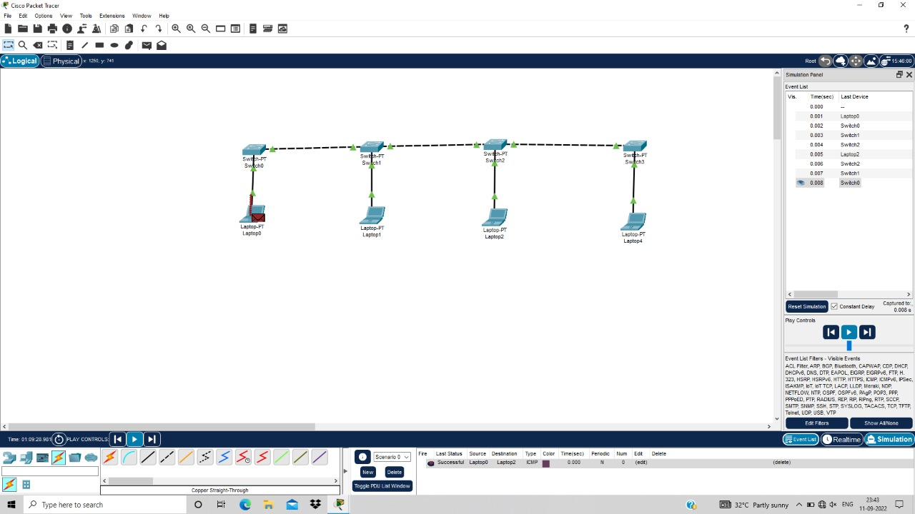

**3.RING TOPOLOGY**

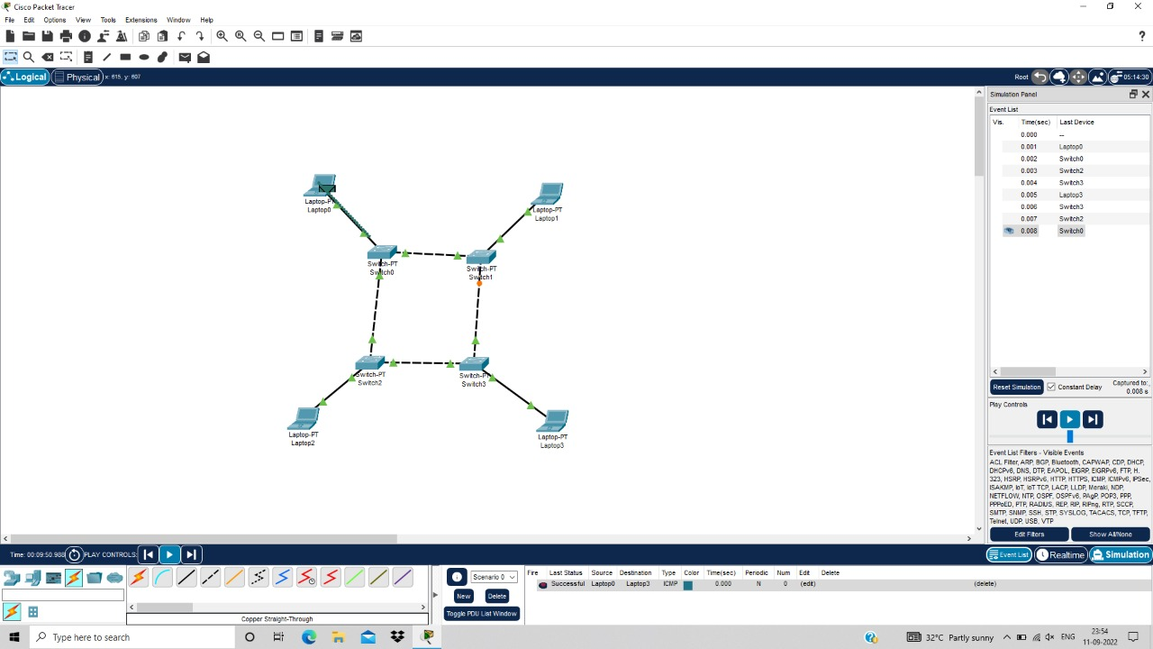

**4.MESH TOPOLOGY**

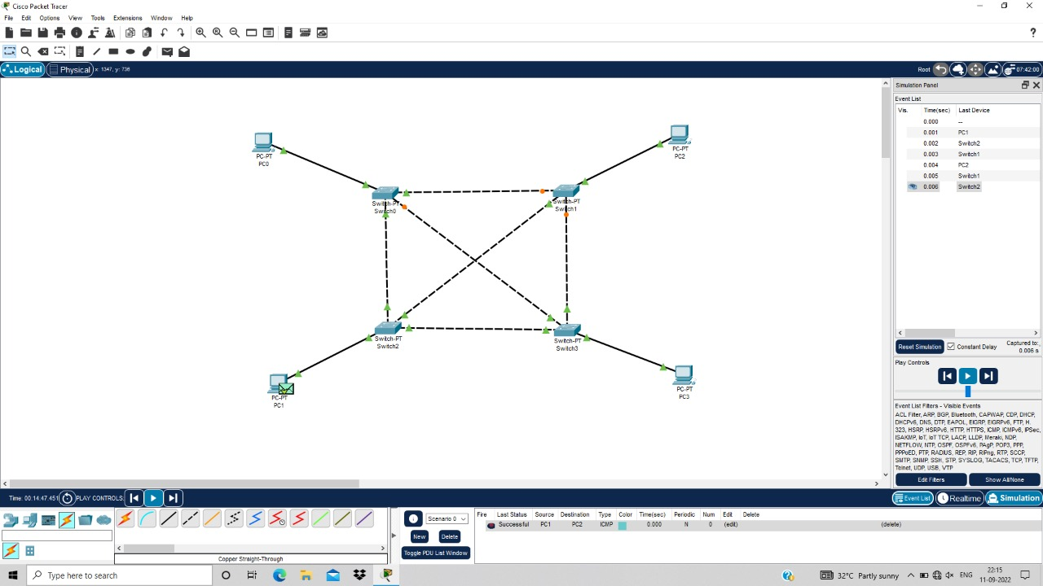

**5.TREE TOPOLOGY**

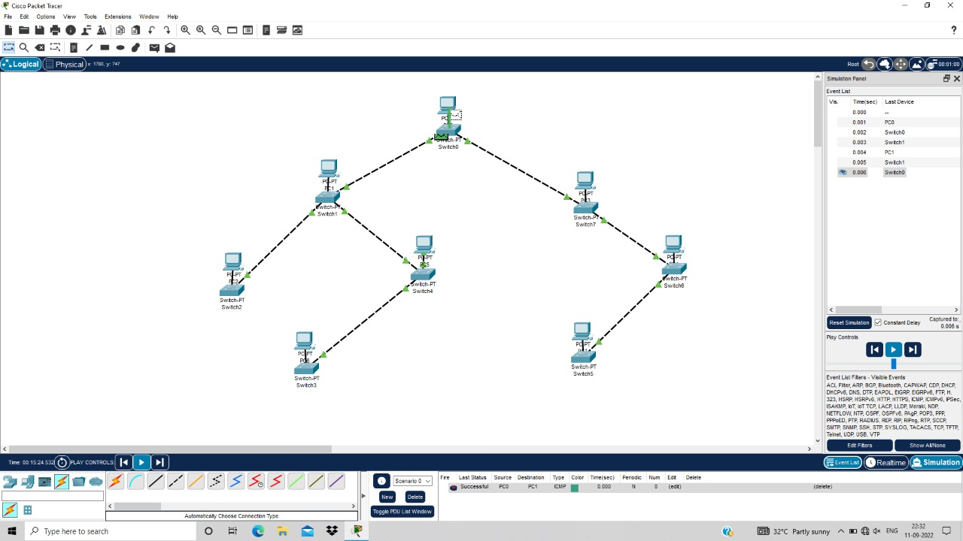

**6.HYBRID TOPOLOGY**

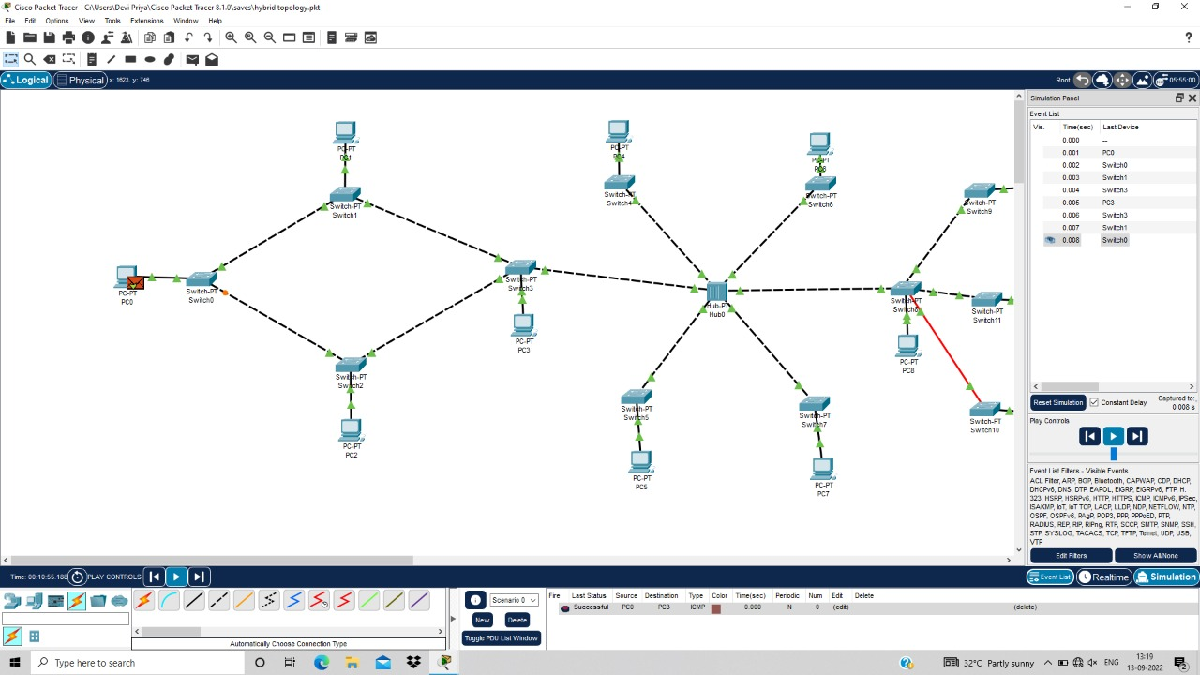

**7.ARP**

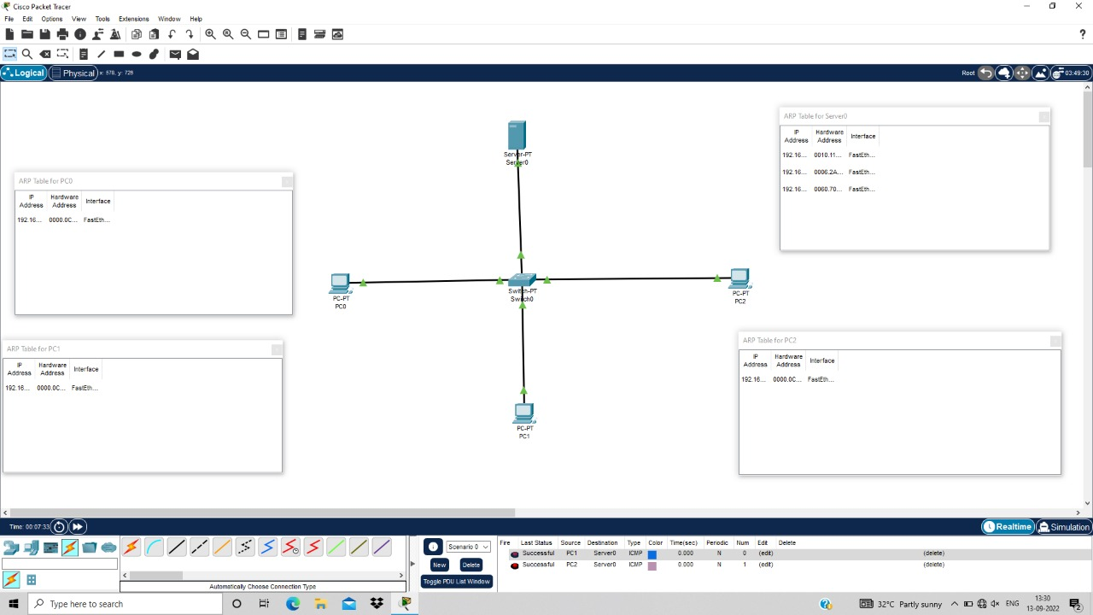

**8.LLDP**

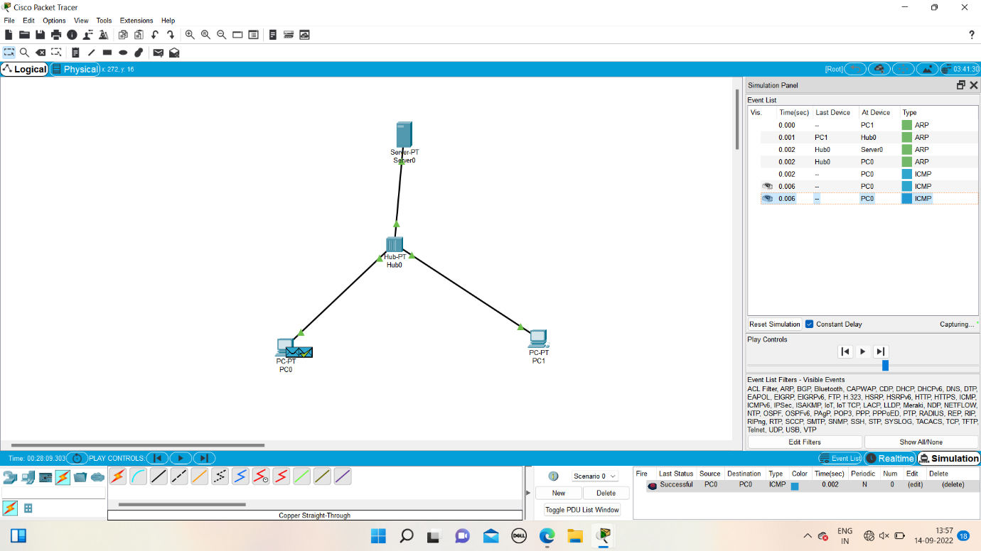

**9. CSMA/CD**

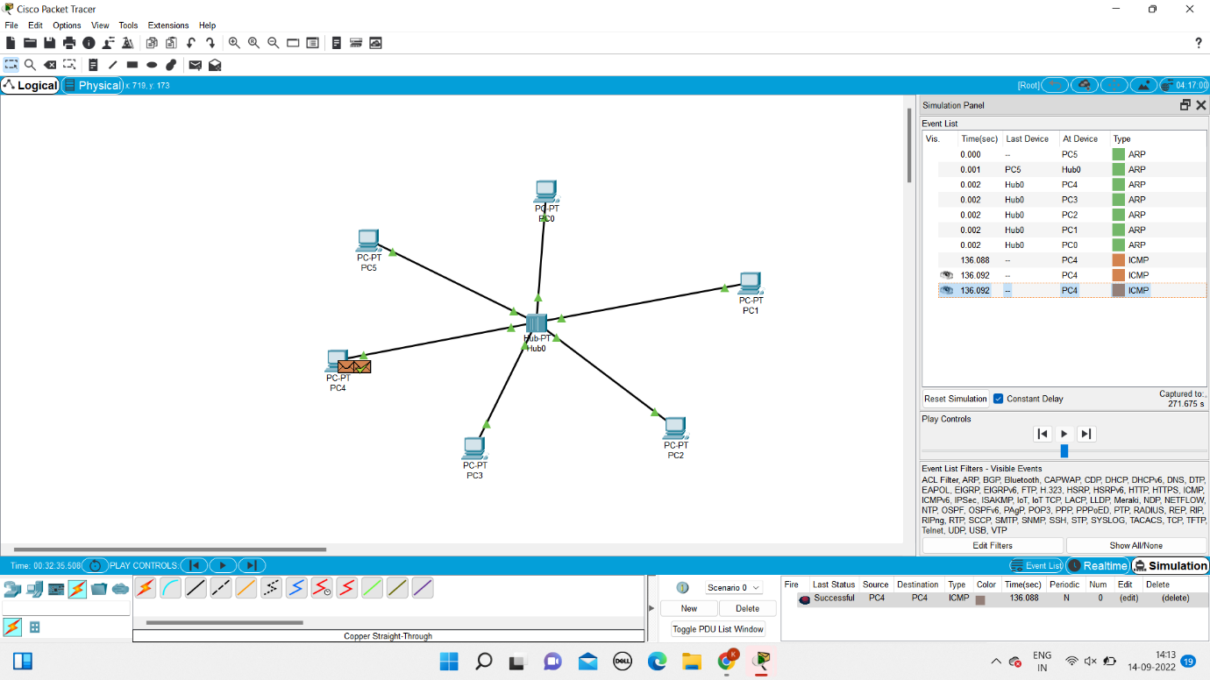

**10.STATIC ROUTING:**

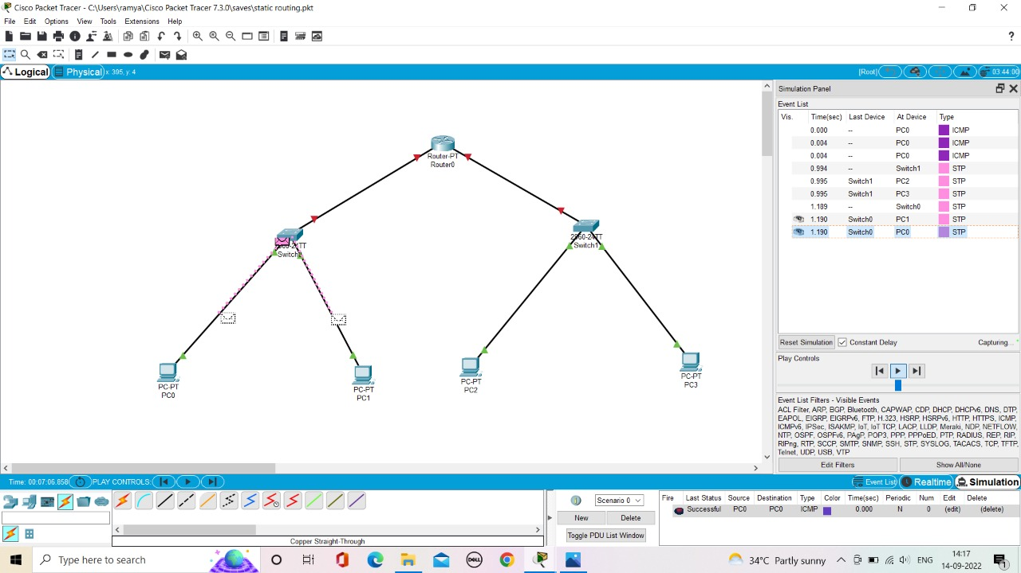

**11.DYNAMIC ROUTING:**

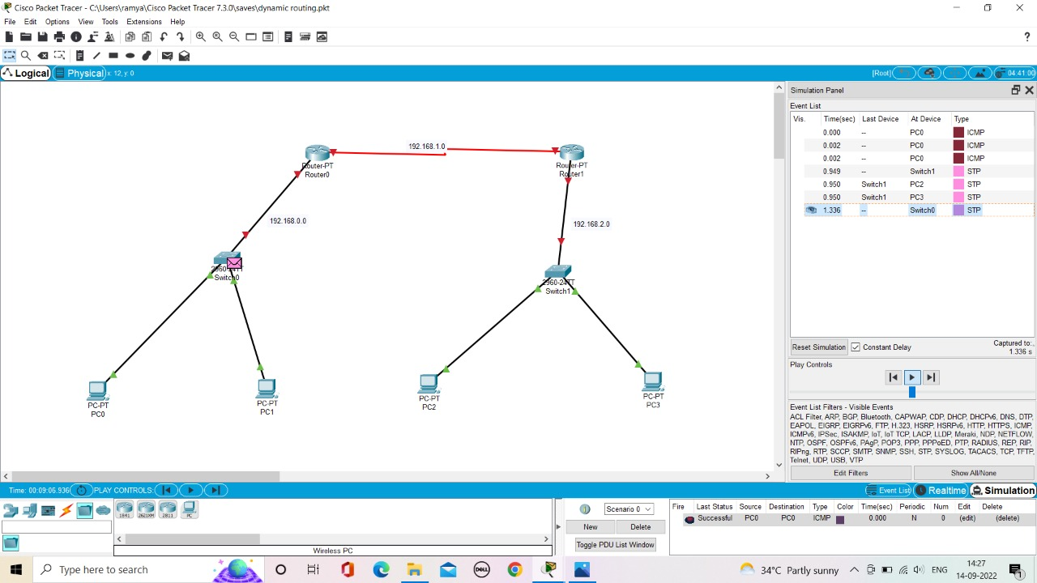

**12.TCP FUNCTIONALITIES:**

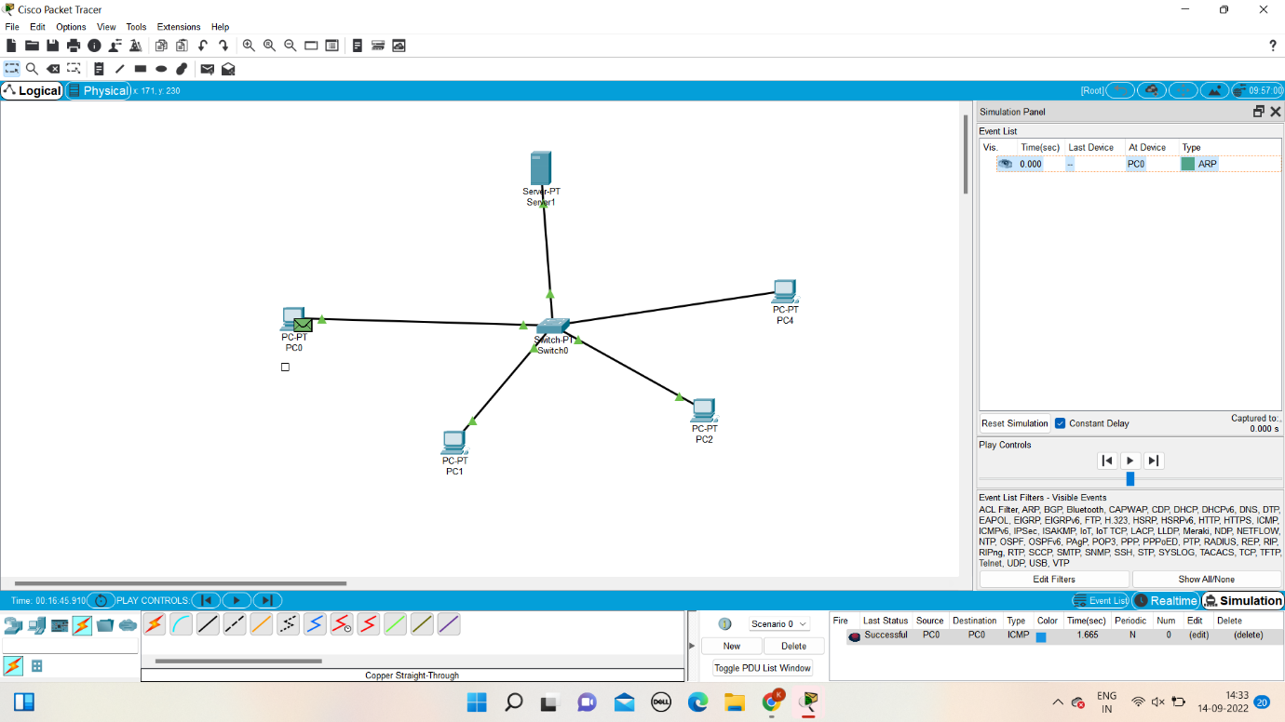

**13.UDP FUNCTIONALITIES:**



**14.TCP EXPLORATION SOLUTION:**



**15.UDP EXPLORATION SOLUTION:**



**16.SUB NETTING:**

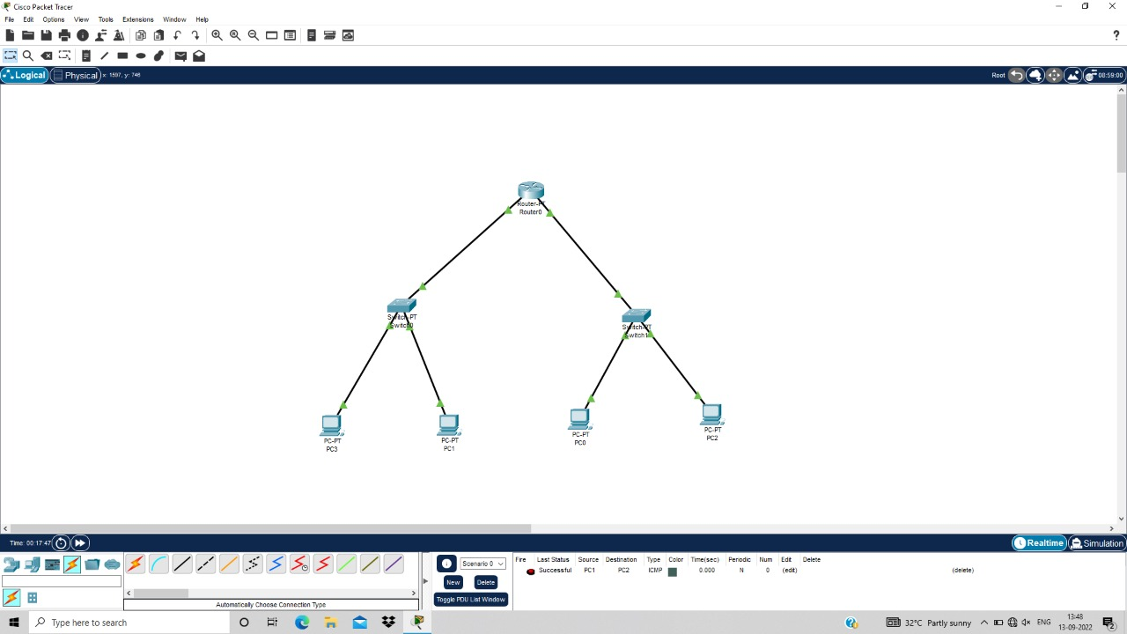

**17.XYZ COMPANY NETWORK DESIGN:**

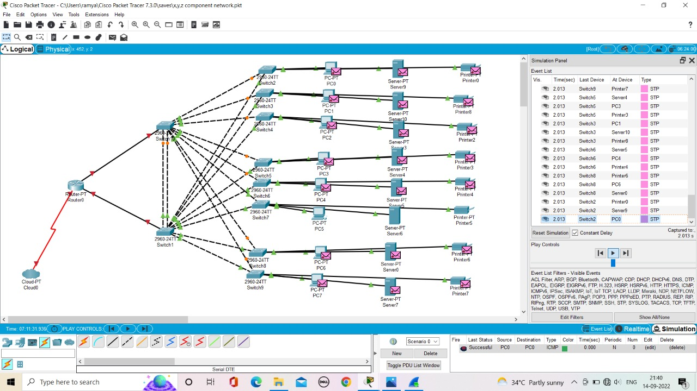

**18.COMPUTER LAB:**

